
Name : Aniruddha Pratap Singh
Year: AY 25-29
PRN: 25070122247
Semester: 3

ASSIGNMENT No: 8
TITLE: Write a Java program to demonstrate the use of the super keyword in inheritance. Problem Statement :
Write a Java program to demonstrate the use of the super keyword in inheritance
Theory:
The super keyword is used to refer to the immediate parent class in Java. It can invoke parent class constructors, access parent class variables, and call overridden methods. Super helps distinguish between parent and child class members with the same name. It ensures proper constructor chaining during object creation. It is an important concept in inheritance and method overriding.
Program :
class Animal
{
String color="White";
Animal()
{
System.out.println("Animal Constr");
}
void sound()
{
System.out.println("Animal SOunds");
}
}
class Dog extends Animal
{
String color="Black";
Dog()
{
super();
System.out.println("Dog Constr");
}
void display()
{
System.out.println("Dog color: "+color);
System.out.println("Animal color: "+super.color); super.sound();
}
}
public class SuperKeywordDemo
{
public static void main(String[]args)
{
Dog d=new Dog();
d.display();
}
}
Output :
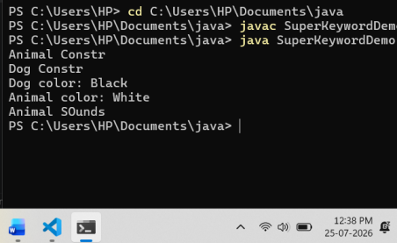
Exercise 1 Create an Employee and Manager program where Manager accesses Employee details using super keyword.
Program :
class Employee {
String name = "Sourabh Gupta";
int salary = 50000;
void displayEmployee() {
System.out.println("Employee Name : " + name);
System.out.println("Salary : " + salary);
}
}
class Manager extends Employee {
String department = "Computer Science";
void displayManager() {
// Accessing Employee details using super
System.out.println("Employee Name : " + super.name);
System.out.println("Salary : " + super.salary);
System.out.println("Department : " + department);
}
}
public class EmployeeManager {
public static void main(String[] args) {
Manager m = new Manager();
System.out.println("----- MANAGER DETAILS -----");
m.displayManager();
}
}
Output:
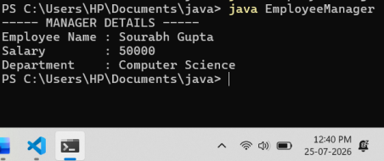Exercise 2. Develop a Vehicle Insurance System where child insurance
classes access parent vehicle information using the super keyword. Source code:
class Vehicle {
String vehicleNumber = "MH12AB1234";
String vehicleModel = "Honda City";
int vehicleYear = 2023;
void displayVehicle() {
System.out.println("Vehicle Number : " + vehicleNumber); System.out.println("Vehicle Model : " + vehicleModel); System.out.println("Vehicle Year : " + vehicleYear);
}
}
class VehicleInsurance extends Vehicle {
String insuranceType = "Comprehensive";
double premium = 15000;
void displayInsurance() {
// Accessing parent class information using super
System.out.println("Vehicle Number : " + super.vehicleNumber); System.out.println("Vehicle Model : " + super.vehicleModel); System.out.println("Vehicle Year : " + super.vehicleYear);
System.out.println("Insurance Type : " + insuranceType); System.out.println("Premium : Rs. " + premium);
}
}
public class VehicleInsuranceDemo {
public static void main(String[] args) {
VehicleInsurance insurance = new VehicleInsurance();
System.out.println("----- VEHICLE INSURANCE DETAILS -----"); insurance.displayInsurance();
}
}
Output:
